**AKENTEN APPIAH-MINKA UNVERSITY OF SKILL TRAINING**

**AND ENTREPRENEURIAL DEVELOPMENT.**

**(AAMUSTED-KUMASI).**

**FACULTY OF APPLIED SCIENCES AND MATHEMATICS EDUCATION**

**DEPARTMENT OF INFORMATION TECHNOLOGY EDUCATION**

A DESIGN SCIENCE RESEARCH ON A STUDENT ATTENDANCE MONITORING SYSTEM FOR PUBLIC UNIVERSITIES IN GHANA.

.

BY:

XXXXXXXX 5181040XXX

XXXXXXXX 5181040XXX

XXXXXXXX 5181040XXX

APRIL, 2022.

**CHAPTER ONE**

INTRODUCTION

* 1. **Background Of the Study**.

Back in 1991, the then Education department (ED) introduced the School Management Initiative (SMI) scheme, which offered a school-based management (SBM) framework for enhancing the effectiveness of schools. In the Report No.7 on Quality Education issued in 1997, the education Commission formulated recommendations to improve school management and performance for the challenges and competition which lie ahead in a global and knowledge-based economy. One of the recommendations is that schools should practice SBM, in the spirit of the SMI Scheme, to develop their own ways of meeting the needs of the students and enhancing learning outcomes (*School Administration Guide, 2021/22).*

The technology advancement into the education system has brought much improvement and has debunk the adages which says “there can never be a classroom without books”. But now, with the digitalization, one can manage a classroom without books. The infusion of information technology in education has made the learning processes even more efficient, cost-effective, and qualitative. It has made it possible for us access information from limitless repositories, libraries and databases from anywhere around the world. No words can actually quantify the immense beauty that information technology has added to education (*Shout Out UK, 2019*).

Technological systems are important tool in managing day to day school operations. Teachers and administrators now have software computer programs house information like phone numbers, addresses and even test scores. Some of them date back to the student was in kindergarten. All this at a few clicks on a computer. Parents can now check grades, attendance and behavior comments without even picking up the phone. Technological systems now track all kinds of information-from parents reporting student absences to teachers recording grades to administrator’s analyzing data (*Kristilynn Turney, Using Technology to manage School operations published on study.com)*

In this technological era of education and doing business, information is considered to be an important asset for any academic institution. The availability of student’s data and feedback can help an educational institution to align its business processes according to the needs of its students and stakeholders. The effective management of these data can help institutions reach out directly to their students and stakeholders and also streamline its activities.

* 1. **Statement Of the Problem**.

School attendance is the daily or regular learner participation in school activities (Gottfried, 2010). Through regular school attendance, learners get to access consistent educational support for their academic attainment (Oghuvbu, 2010). When learners attain academically, Honneth (1995) observes that they recognize their identities and intersubjective awareness of their social and individual capabilities. However, Epstein and Sheidom (2002) assert that regular school attendance is a commitment to finalization of a full academic program.

Irregular attendance can lead to higher repetition and dropout rates, as well as low levels of learning. Irregular attendance of school attendance renders all global and national efforts towards universalization of education unproductive. A variety of factors can cause irregular attendance and difficulty in attending basic school, such as:

* Combining work and school has been shown to increase absences and hurt educational performance, often leading to school dropouts (UNESCO, 2015).
* Attitudinal barriers and school’s climate pose serious constraints to children’s attendance, participation and learning in schools.

Superintendent of Schools Thomas Ciacicio said “Beyond that, understanding the importance of good attendance helps instill character traits like persistence, resilience and responsibility. Research shows that, students regardless of gender, socioeconomic status or ethnicity, fall behind academically when they are chronically absent (*The Fonda-Fultonville Central School District Report, 2021).*

In the widely cited paper “Do students go to class? Should they?” Romer (1993) examined the relationship between class attendance and academic performance and found that class attendance has significant and positive impact over academic performance. Therefore, he recommends for mandatory class attendance policy for enhancing academic performance (*Academic Paper, 2018).*

Good record keeping is very essential to the overall success of the school system. Poor management and maintenance of records about the school and students can mar the success of the whole system. According to Akinwumiju and Agabi (2008) information is a vital tool in the socio-economic development of any human society and information carefully gathered, stored, retrieved and transmitted through various media has helped in maintenance and sustenance of human society since the history of man. A poorly managed information system according to Ujah (2016) could ultimately result in the organizational disharmony and conflict. The adoption of a good information management system is very essential as Ujah (2016) asserted that, educational thrives mostly on information in the same way that counselling effectiveness hinges on good, sufficient and timely information dissemination (*E.E Achor, S.M. Kurumeh & T.T Udu, 2018).*

Due to the challenges and related problems which normally generated on the student’s attendance between the school management, teachers, parents and other stakeholders, it is very prudent for the researcher to dive into the issue and design a system to monitor the students’ attendance to school and classroom respectively and keep proper information on each student.

**1.3 Aims and Objectives of The Study**

The study aims at investigating and analyzing the situation of student attendance and come out with an effective and efficient student attendance monitoring system which can keep proper track on the student’s attendance in Junior high school in Ghana. The research will give enough knowledge on the impact of attendance on academic performance and proper security measure to protect the students and also defends the school administrators after handed the students by their parents to the school.

The following are some specific objectives that guides the researcher in the study and the designing of the system:

* To track and store the records of the student’s attendance to school and class during each instructional period.
* Periodic dissemination of updated status on student’s attendance information to the school administration and the parents of the ward.
* The proper medium to keep and also the ability to retrieve the records on the student’s attendance for decision purposes.
  1. **Research Hypothesis**

To ensure that the research finding and its methodology meets the scientific standard and the can be justifiable, the following hypothesis were adopted to guide the research for efficiency and reliability. They are:

* The student attendance records are the datum for proper decision making on the performance of the student.
* Regular school and class attendance have diverse impact on the student performance.
* The student attendance records are the efficient security measure to defend the school and the student as a whole when the need arise.
* The student attendance monitoring system is an effective tool to check truancy of students.
* The student attendance monitoring system motivates students to maintain discipline attendance records in the class.
  1. **Significance Of the Study**

A sound student attendance monitoring system is the expectation of parents, school administration and other stakeholders. The student’s attendance monitoring system which tract student’s punctuality, absenteeism, eliminates data-duplicity and errors and reduces paperwork and saves time and money has the following as the key significance and betterment in decision making. The student’s attendance monitoring system has the capability to:

* Improve School Security
* Render instant Notification to parents
* Attendance tracking in Real-Time
* Enhance Student Performance

**1.6 Scope of the Project**

The purpose of this study is to produce a very reliable system which is efficient to allow student to Sign Up, match student’s fingerprint for verification, Sign Out, Sort termly attendance and generate students termly attendance report for the purposes of assessment. For that matter, only Junior High Schools in Ghana are factored in this study. This system will be designed to suit the two-tier architecture. This system will have a remote server to house the database where all other computers will access information remotely. This system is therefore a client-server application.

* + 1. **Limitation of the study**

This study might be confronted with a number of challenges which could impede the efficiency and validity of research. There will be an activity of collection and gathering of vital data and denial of such records could influence the generalization of the study.

Improper analysis and interpretation of the user and system functional requirement provided has a diverse effect on the software development. Mobile systems application has a massive patronage as compared to that of desktop system application. But the researcher will use desktop system version of application to verify and validate the efficiency of the system.

Finally, there will be a financial and time constraints which can narrowed the general objective of the study.

* 1. **Organization Of the Project**

This study has been organized into five (5) chapters.

Chapter One which the introduction to the study consists the background of the study, statement of the problem, aims and objectives, research hypothesis, significance of the study, scope and limitations, organization of the study report and the summary of the chapter.

Chapter Two involves the review of related literature which will enhanced and broaden the horizon of the researcher on the field to be researched. On this study, the researcher will vividly dive into concepts of electricity, brief history of the electricity and current situation on the power sector and finally the mode of billing the customers.

Chapter Three, discussions of the methodology used in the study which the emphasis will be on the research design, research setting, Data collection instrument, Ethical consideration, Description of the proposed system, and finally the system development and summary of the chapter.

Chapter four, the system demonstration and evaluation; at this juncture, the researcher performs the experimentation and evaluation on the system as to whether the functional requirement of the system has been met.

Chapter Five as the final chapter of the research study will provide a quick summary of the entire system and the study as a whole with further recommendations and conclusions.

* 1. **Chapter Summary**

Technological systems are important tool in managing day to day school operations. Teachers and administrators now have software computer programs house information like phone numbers, addresses and even test scores. Parents can now check grades, attendance and behavior comments without even picking up the phone. Technological systems now track all kinds of information-from parents reporting student absences to teachers recording grades to administrator’s analyzing data. This study introduced a new technological system which will aid in motoring the student attendance and also kept records for future use.

CHAPTER TWO

**LITERATURE REVIEW**

**2.1 INTRODUCTION**

The chapter entail the review of related literature concerning the conceptual and empirical review and the theoretical framework of attendance monitoring systems and their usefulness in education and finally the Impact of attendance on children’s academics.

**2.2 Concept of Attendance Register**

School attendance is the daily or regular learner participation in school activities (Gottfried, 2010). School attendance is an important factor that influences the academic performance of pupils. Roby (2004) School Attendance Hypothesis indicates that regular school attendance could help pupils to achieve academic excellence. Similarly, Fleming (2008) advises that pupils

need regular school attendance for them to be highly engaged with classroom activities. The attendance record is regularly reviewed by the head-teacher and the district inspector of schools as a quality assurance measure (Nsubuga, 2008).

Academic attendance register on the other hand, is a very important and compulsory tool in the process of learning; it helps lecturers track students individually and measure their interest. Academic attendance is indeed one of the key factors that determine students’ performance (Durden & Ellis, 1995). Attendance does matter for academic achievement (Durden & Ellis, 1995); but attendance itself is associated with school and family factors as well, such as the presence of an engaging learning experience, experienced and skilled teachers (Chang & Romero, 1998 cited in Rel West, 2011). Paredes and Ugarte (2009) provide evidence that attendance is a main factor affecting student performance, and indicate advantages that merit policies regarding minimum attendance. Johnston (2000) underlines that the aim of applying measures to control academic attendance is not to penalize or punish students but motivate them and bring all the necessary attributes together to achieve academic success.

**2.3 Empirical Review on student Attendance and Achievement**

There have been many studies that have explored the correlation between student attendance and student achievement. Jones (2006) discovered that research has shown a direct correlation between good attendance and student achievement. Jones (2006) further suggests that poor attendance has been linked to poor academic performance. More (2003) Says that the results of his research indicates that improved rate of class attendance were associated with improved academic performance and the emphasis on the academic benefits of class attendance were also effective.

Biegel (2000) in a study carried out to determine the interfaces between attendance, academic achievement and equal educational opportunities in the US, observed that there is a direct correlation between class attendance and academic achievement. He explained that students who go to class invariably do better in school and they maximize their chances for success in their academic.

Van Blerkan (2003) also studied why students missed class from that research, it was reported that the most frequent reasons given by the students were: becoming discouraged and believing attendance have little effects on their grade. In a follow-up study (van Blerkan 2003) found fairly low correlation between academic perseverance, self-efficiency, class attendance and

course grades.

In an attempt to control attendance (Berenson, Carter and Norwood, 2000) put in place a „Compulsory attendance policy” that combined reward and punishment protocols in which student were allowed three unexcused absences with additional unexcused absences possibly resulting in dismissal from the school. Eventually students with no more than one absence between exam dates were awarded five pants for that exam score. Consequently, there was improvement in attendance rate and the study showed that increase attendance rates correlate with increased achievement. With this result in mind, Brenson, Carter and Norwood (2000) therefore concluded that “It is highly likely that group policies such as enforced attendance, will have an impact on students’ academic performance”.

**2.4 Theoretical framework: The Solow effect theory**

This study is situated within David Romer’s (2001) Solow Effect Theory. The theory assumes that school attendance is one of the major determinants of institutional performance (Burke and Beegle, 2004). According to Orazem and Gunnarsson (2003), the Solow Effect shows the relationship between school attendance, academic performance and social productivity. Bhattarai (2017) supports this idea by arguing that social productivity depends on physical capital, labour, human capital and knowledge that ultimately impacts innovation and growth. Todd and Wolpin (2003) add that the purpose of schools is to develop human capital and knowledge to support the social productivity role of citizens.

Ramirez and Boli (1987) also argue that a positive relationship between human capital per worker and the output per worker determines the social productivity function. Klenow and Rodrigruez-Claire (1997) contemplate that the academic achievement variable can be used to measure human capital per worker. According to Rana et al. (2015), academic achievement is measured by the number of school years and the intellectual performance registered. There is conventional wisdom that when a society educates its workers, they will add quality to the stock of human capital produced (Bils and Klenow, 2000; Todaro and Smith, 2015). Finally, school access and regular attendance, satisfactory progress and completion are variables that make a significant impact on educational achievement (Thapa, 2013) and human capital attainment (Dubow et al., 2009).

**2.5 Impact of Attendance on Academic Performance**

Empirical evidences have shown that there is a significant correlation between students’ attendances and their academic performances (*Newman-Ford et al, 2008*). There was also a claim stated that the students who have poor attendance records will generally link to poor retention (*Marr, Liz et al, 2005*).

This is also agreed by Mazza and Dimitrova where they both claimed that the students’ attendances to the course may indicate their behaviors towards the subject where it can be used to judge their tendency and commitment to the course (*Mazza, R. & Dimitrova, V., 2004*).

However, even though arguably there are many other reasons that could explain why the students are poor academically such as lack of preparedness, financial problems and poor accommodation, most of the previous studies agreed that the students who fail to attend the classes will inevitably engage with difficulties in the future (*Newman-Ford et al, 2008)*, (*Bowen, E., et al, 2004).*

Results taken from the study done by Newman-Ford, Lloyd and Thomas have shown that attendance was a significantly better predictor of grade than any other factors such as age, prior education background or even gender (*Newman-Ford et al, 2009)*. From the study, it had also revealed that retention rates were substantially better for students who were consistently attended classes than those more frequently absent. All of these findings have showed that attendance records have primarily become the proxy to determine the success of the students in most of the higher academic institutions.

CHAPTER THREE

**RESEARCH METHODOLOGY**

3.1 **Introduction**

The methodology chapter of research design contains several aspects which ranges from the appropriate research design approach selected to build the study to the last most section on which the researcher vividly explores on the system development life cycle on the intended system. The various areas contained in this section are listed below.

The first aspect thus research design/approach is the part of the study which discusses the researcher intentions and reasons for the selected approach and also emphasize on the research setting as the cultural, physical or social setting in which the experimental study is conducted.

Data (Requirements) collection instrument; explains the specific tool(s) the study employed to collect the data and how to deployed the tools. Since a sensitive data is required for the study, appropriate ethical consideration is employed in this chapter to protect the privacy, confidentiality and the health of the research subject.

Finally, the description on the proposed system and system development/building which includes tools, development process, system development life cycle (SDLC) has been thoroughly address in this chapter and the completion of the chapter lies the chapter summary.

**3.2 Research Design/Approach**

The research design as the roadmap for the successful completion of the intended research work.

Kothari (2004) expounded that, a research design is the arrangement of conditions for collection and analysis of data in a manner that aims to combine relevance to the research purpose with economy in procedure. And further added that, Research design, in fact, has a great bearing on the reliability of the results arrived at and as such constitutes the firm foundation of the entire edifice of the research work.

The study has a central focus on the approach that allows findings in context and enhance richer details to its conclusion, and for that matter, the researcher explored and was meticulously convinced to espouse a quantitative strategy called experimental research design which can aid in a generalizability and credibility of the research findings.

The experimental research has a merit of helping the researcher in gathering the necessary data to make a sound decision on the findings. Most importantly, experimental research is completed in a controlled environment. The researcher collects data and results will either support or reject the hypothesis and also data in experimental research must be able to be quantified, or measured. These types of observations help supplement the measurements taken throughout the experiment (*Babbie,1998*).

**3.3 Research Setting**

In the research setting, the environment within which studies are run has important consequences on the experimental design, the type of data that can be collected and the interpretation of results as a whole.

This system was intended to use in all the lecture hall of university colleges in Ghana but for experimental study on the effectiveness, efficiency and reliability of the system, Faculty Block of Information technology education within a AAMUSTED campus which precisely, contains the level 400 student with total population of approximately ninety-four were compared to be used by the researcher to carry out a piloting experiment to show whether the system could respond to the hypotheses under the study or there need to be further modifications.

The sample class indicated for the study were registered and their information stored on a central database system. Each student attendance to lectures would be recorded and confirmed by a biometric system after the student places the fingers on biometric machine mounted at the gate before and after each lecture of the day.

Strict measures were adopted to regulate the process and provides the necessary support measures education for the experiment to produce a reliable and valid result which is free from bias.

**3.4 Data (Requirements) Collection Instruments**

The data collection tool or instrument which the study employed is observation

**3.4.1 Observation**

In the University setup, each student attendance to particular lectures has a diverse proportion to their performance at the end of the semester and for that matter, keen attention was needed to observe the student behavior during the lecture’s hour. During the experimentation, some peculiar characters were thoroughly observed and recorded for decision making which includes the time of entering either late or early prior to lecture hour, duration spent on particular lectures, and various assessments on a course.

During the observations, the researcher refrained from having negotiations in any form or asking the student questions but solely dwells on observing the actions and reactions of the learners.

**3.5 Ethical Consideration**

Education on the personal hygiene is the pivotal and paramount factor to be considered when using the biometric finger print to take information from user. Contagious Disease and infection could spread from infected person to most of the students if proper sanitization exercise is not performed on the devices frequently. To avoid this infectious disease guidance and healthy protocols like washing of hands before putting fingers on the biometric machine were instituted.

To add on, the place where the biometric device and other supporting system was considered to be free from dust, liquid and whether conditions which could hinder the proper functioning of the system or may even spoilt the system.

Proper arrangement of cables and electrical lines were also put into consideration, since it might cause accident and damage to the students. Strict protection and monitoring on the device were much observed to prevent bad people which could temper the device to affect the proper functioning and mislead the finding to produce invalid and non-reliable results.

Finally, permission was besought and granted from higher authority to have access to the students and other resources which could aid the research to the success.

**3.6 Description of the Proposed System**

The student attendance monitoring system for public university in Ghana is a 2-tier architectural desktop application consisting of front-end which was programmed in the Microsoft visual basic and the back-end host the database made by MySQL which stores the daily records for future retrieval purposes for decision making.

Attached to the system is biometric finger print scanner which scan and validate the student by matching hash keys from the scan finger with the one already stored on the database. If the finger print matches, it assigned an increment of one stroke to that of the individual accrued attendance record.

The system has embedded with crystal report which could be used to generate a comprehensive report at end of each semester to be used as the bases of decision making on student performance exhibited throughout the said semester. Having fair knowledge of each student could reduce discrepancies arise from making decision on the assessment of the student performance.

**3.7 System Development/ Building**

System development or Building as a process of defining, designing, testing and implementing a new software application or program. This section has been grouped according to tools and the development process which contains the system development life cycle (SDLC).

**3.7.1 Tool**

The study intended to develop a complete system which could aid the researcher in the experimentation stage of the study. But due to time and financial constraint on the system development, the prototype of the proposed system as the rapid version were planned and built by the researcher to validate and authenticate on the efficiency, effectiveness and reliability. For that reason, the researcher taught of rapid system development tool with better graphical interface and compatibility.

This study agreed on the Visual Basic programming as the tool which could be needful for the building of the prototype version of the system. Visual Basic is one of the most important programming languages having a powerful front-end tool which is able to achieve simple and complex business requisites in and effective and efficient manner. Visual basic was derived from Basic and enables the Rapid development (RAD) of graphical user interface (GUI) applications, access to databases using Data access Objects, Remote Data Objects, or ActiveX Data Objects, and creation of ActiveX controls and objects.

MySQL is an open source and the back-end for this very project. According to (w3schools.com) SQL is a standard computer language for accessing and manipulating databases. SQL stands for Structured Query Language. It is an ANSI standard computer language, allows you to access a database, can execute queries against a database, can retrieve data from a database and it is easy to learn. Looking at the various merit and reliability in case of storage and retrieval of information for decision making, the project to preferred to use MySQL to remaining databases.

**3.7.2 Development Process**

Benjamin Franklin once said “If you fail to plan, you are planning to fail.” Every great piece of software starts with a plan and a clear process in place. There is numerous software development process but the question is Which one is applicable for the proposed system under study?

The study employed the Rapid Application Development model (RAD) as the process of software development due to its powerful development tools and techniques. The Rapid Application Development process based on the prototyping without any rigid format for planning. The RAD model has the following features which attracted the attention of the researcher to compare to other models of software development.

The Rapid Development Model:

* Has short time span i.e., the time frame for delivery (time-box) is generally 60-90 days.
* The use of powerful developer tools such as Visual Basic is also integral part of the project.
* Each phase in RAD brings highest priority functionality to the customer.
  1. **The System Development Life Cycle (SDLC)**

**3.8.1 The Planning Phase**

During the planning phase of the development of the system to monitor the attendance of public university in Ghana, the sample size, duration, budgeting were the main activities performed by the researcher.

* Population

The prime and focal target population for the study was implicitly public university students but due to financial and time constraints, the researcher narrowed the scope to involve only students at AAMUSTED-Kumasi campus of Ghana as assume population for the experimentation. Upon further considerations, a Faculty within the University campus were targeted for this project.

* Sample Size and Sampling Techniques

Based on the study, and time required to implement the system for the experimentation to be effective, the researcher was convincedly adopted a purposive sampling technique to select particular class in the faculty of information technology education precisely level four hundreds. The sample size estimated for the experiment were exactly 50 students in the ITE level 400B.

* Budgeting and Duration of the study.

The project team estimated consist of three members namely Veraxx, index number xxxxx…. All in the Information technology department of AAMUSTED Kumasi campus. The duration for study, development of the deliverable and experimentation sum up to approximately 65 days.

An initial ransom amount of money in the Ghana cedes was set aside as the budgeted amount to catered for the transportation, purchases and miscellaneous on the project team and project as a whole.

**3.8.2 Analysis Phase**

Requirement solicitation were conducted by the project team to gather the system specification based on the functional user and system requirement. An interview was organized between the project team and entire lecturers from designated faculty for the experimentation. During the interview, a questionnaire was given to each participant to state emphatically on intended requirement of the system. Below is the specification document on type of system software, the functional user and system requirement gathered from the interview.

* **Type of System Software**

The study intended to produce a system of systems comprises of the embedded control and information system application which would be in the 2-tier architecture thus, its system has connectivity to a database at the back-end to store information and also a biometric system which will send the finger print hash keys to the database for confirmation and validation. The current information provided by the system has the capacity to store permanently to aid in decision making.

* **User Functional Requirement**.
* Entry to enroll new user to the system
* Ability to sign into the system
* Provision to take snapshot of the user
* Provision to take finger print of the user
* Entry to create new semester schedule
* Ability to access information and generate report
* **System Functional Requirements**
* Sign up a new user
* Authenticate and log in a registered user.
* Search engine to retrieve records on user
* Save, update and preview user records
* Ability to record timely attendance of the users
* Create and update semester schedules with necessary reminders
* Verify and authenticate finger prints
* Ability to upload a profile picture
* Generate and produce a valid attendance report on the user.

**3.8.3 Design Phase**

This section contains the diagrams describing the proposed system in which the researcher purported to design based on the analyzed requirement specification.

* **Use Case Diagram of Attendance Monitoring System**

Activity Menu Launched

Log In

Sign Up

start

Already sign Up?

**SYSTEM**

**USER**

Create Course schedule

Register Students

Log Out

Cancel

Save

Take Attendance

* **Use case Description**
* Actors:

1. User: This refers to either the Administrator which could be a Lecturer at the university or IT specialist in charge of the system and Students whom their attendance will be recorded.
2. System: This consist of the biometric finger print and system application in charge of monitoring the attendance of the users.

* Log In: This interface is responsible for either signing in a new User (Lecturer) or authenticate and validate already signed up user into the system to have the administrative authority or conduct an attendance on students to a particular lecture.
* Activity Menu: This displays the system activities to aid the motoring of the attendance. The menu consists: the create course schedule, enroll new student, take attendance and generate report.
* Create course schedule: Provision is made here for each lecturer to draw his/her semester time table and also register students that has been assigned to the class.
* Register Student: The panel provides a sign-up form to add, update and delete student from/to a particular course.
* Take Attendance: Before every lecture began, a biometric attendance register is marked by the lecturer to record the number of students attended with history of their time of entering and closing for that instructional period.
* Save: The save button when pressed by the user will move the record and save to the database for permanent storage and future retrieval of the information.
* Cancel: Terminate and drops the records added to the database and exit the user from taking the attendance.
* Log Out: Changes the interface to read only.
* **Activity Diagrams of Attendance Monitoring System.**
* System Sign-Up and Log-In Activity diagram

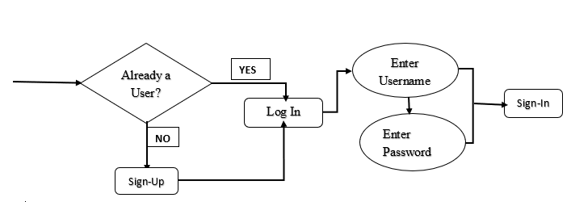

* Create Course Schedule Activity diagram

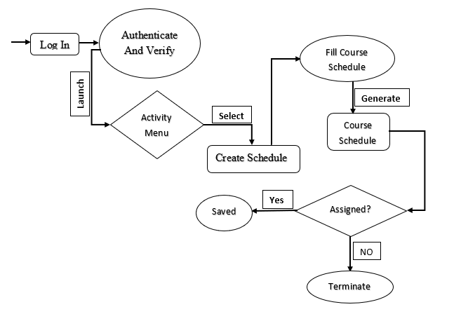

* Enroll New Student Activity Diagram

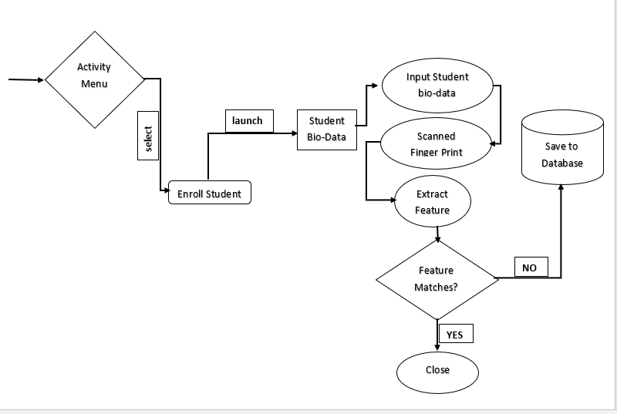

* Take Attendance Activity Diagram

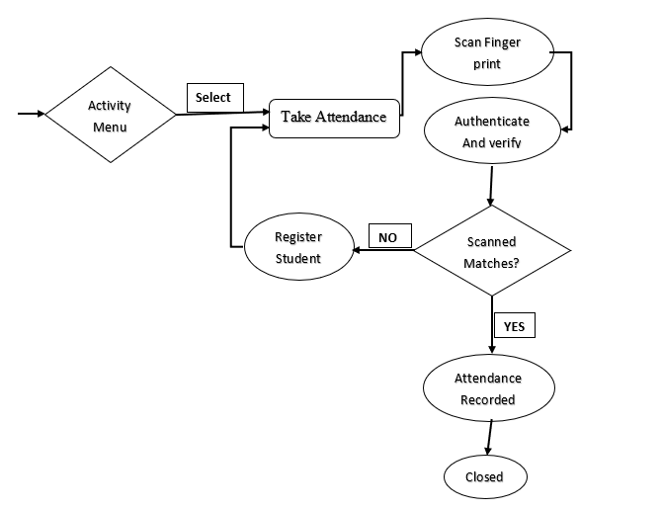

* **Components Design**

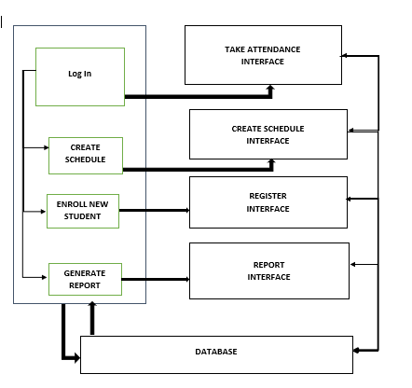

* **Database Schema**

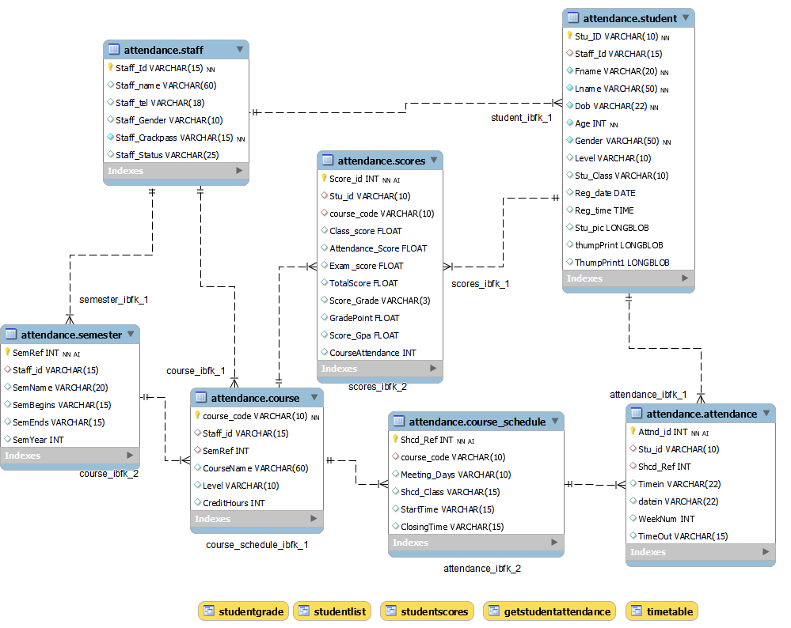

**3.8.4 Implementation Phase**

The project team after thoroughly scrutinized and analyzed the system specifications were realized to break up the components into front-end and back-end. Whereby those team members belonging to the front-end performed the various coding on each component units with the Visual basic programming tool whilst those with much skills in MySQL handled the writing of queries for the Back-end which is the databases. After everything each component were joined together to proceeds for system testing and evaluations of which much information has been stipulated under chapter four and five respectively.

* 1. **Chapter Summary**

This chapter vividly elaborates on the methodology on which the data needed for this study findings would be collected and analyzed and with the appropriate system development life cycle. The study adopted quantitative method of research approach with experimental research as the quantitative strategy employed to collect and handle the needful data for the research.

The Rapid Application Development (RAD) were used as the model for the software development and visual basics and MySQL were the programming tool employed by the study in designing and coding the front and back end respectively for the system and its components. In conclusion, the used case diagram, activity diagram and components design with their respective descriptions were also considered.

CHAPTER FOUR

**SYSTEM DEMONSTRATION AND EVALUATION**

**4.1 Introduction**

The chapter highlights some demonstration of the system for various platform compatibility and the system software requirements and unit testing, system testing, integration testing, acceptance testing was conducted to evaluate the system.

**4.2 System Demonstration**

The very critical stage in the quest to produce a very efficient and reliable system to monitor the course attendance of student in AAMUSTED-Kumasi on their punctuality and availability throughout a course lecture section is the system demonstration stage.

In the teams’ system demonstration, the prototype was presented to the customers to validate the performance and feasibility of the system whether it meets their desired requirement or a need to redesign another version of the system.

The team assembly the needful hardware and software which will enhance the experimentation of the prototype system.

**4.2.1 Experimental Setup**

The experimental setup is the initial stage of the system demonstration where the team performs numerous of testing to come out with the efficient platform compatibility, software and hardware specification of the system prototype system for evaluation.

**4.2.1.1 Platform Compatibility**

The system was tested on different platforms such Mac OS and windows for their compatibility. It was realized that, the system worked well after the installation on the Microsoft windows but not supported by Mac OS.

The software is compactible on any of the following window’s type, namely: the Microsoft windows 8, 10, and 11 with a Net framework vary from 4.0 to 6.0 and processor speed of 1.8 Giga Hertz and above.

**4.2.1.2. Software And Hardware Requirements**

In order for the system to run on the one Microsoft windows, there should be a supported application which needs to be installed. These are:

1. MySQL application which will hold the database of the system
2. Installation of supported drivers for the biometric finger print devices.

The system makes use of the following hardware components, namely: personal computer and Biometric fingerprint scanner.

**4.2.2 Experimentation**

* **System installation**

MySQL database application which would be the back-end of the system were downloaded and installed successfully on the Microsoft windows-10 with net framework of 4.5 and processor speed of 2.4 giga Hertz dual and the various table elaborated in the entity relation diagram were populated into the database. The Executable file were created with Advanced Installer application. The setup file was installed on the said machine successfully.

**4.3 System Evaluation**

**4.3.1 System testing**

Software testing is a process to evaluate the functionality of a software application with the intention to discover whether the completed software follows the specified requirements and identifying defects to ensure the software product is defect free. (Hetzel, 1984) defines software testing as a process of establishing confidence that a program or software system does as what it is supposed to do. On the other hand (Myers,1979) defines software testing as the process of executing a program or system with the intent of finding errors

* **Unit testing**

Unit testing is a type of functional testing procedure where the expected output of an activity during the use of a software component is compared with the actual output**.** The team employed white testing since the tester has full knowledge of the internal implementation details and structure of the code. Below is the various unit testing on the components of the system.

Unit Testing for The Admin login

|  |  |  |  |
| --- | --- | --- | --- |
| Test | Steps | Expected Results | Actual Results |
| Install software | Double click on the installer  Follow the installation prompt | Software correctly installed | Installation was successful |
| Login pass | Input the username  Input the password  Click on the login button | Login to the System main page. | Access Granted |
| Login failed | Input the username  Input the password  Click on the login button | Denied access to the system main page | Invalid username or password. |
| Display data | Automatically query the data from the server | Show data on the Main page | Displayed successfully |
| Log out | Click on the logout button | Takes user to login page | Successfully logout |

**Figure 4.0**

**Administrator login page.**

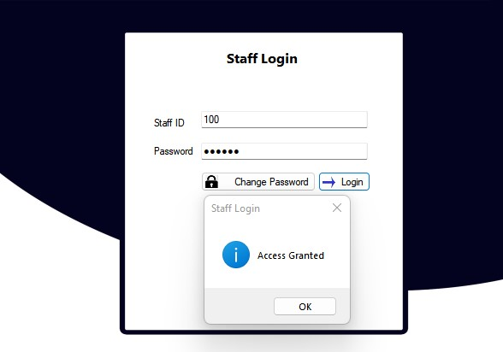

Unit Testing for Components of the System

|  |  |  |  |
| --- | --- | --- | --- |
| Test | Steps | Expected Results | Actual results |
| Enroll New Student | Click on the Enroll New student button  Fill all credentials prompted | System should check if student does not exist in the database | You records have been save successfully |
| Add finger Print | Scan finger print to update student records | System should recognize the finger print and capture finger print template. | Finger print saved successfully. You may capture another finger Print |
| Create course schedule | Click the create course schedule  Assign the course and duration. | Able to create course schedule for the semester. | Course schedule created successfully |
| Take Attendance | Log in as a admin  Scan the student’s fingerprint | Automatic update the attendance records of the student. | Attendance successfully taken. |
| Generate Report | Click on the generate report button | Automatic generate student report | Report generated successfully |
| Connect Finger print | Connect the pins of the finger print scanner to the appropriate pins | The yellow LED fingerprint scanner should blink and stay on steadily | The yellow LED of the fingerprint blinked and stayed on. |

**Figure 4.1.1**

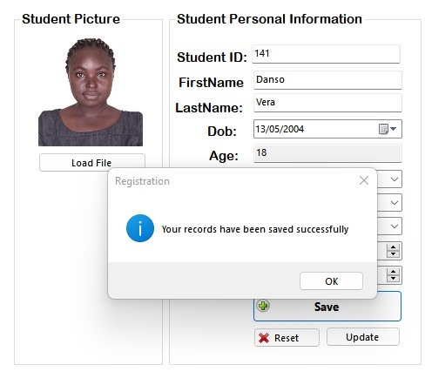**Student enrollment page**

**Figure 4.1.2**

**Student enrollment page**

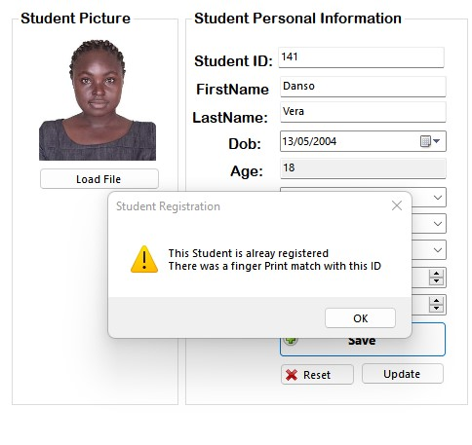

**Figure 4.2**

**Adding Finger Print page**



**Figure 4.3**

**Course Attendance Page**

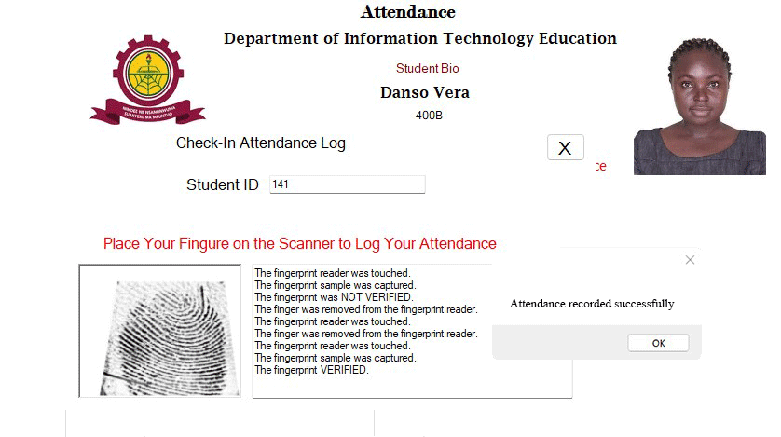

**Figure 4.3**

**Course Attendance Records**

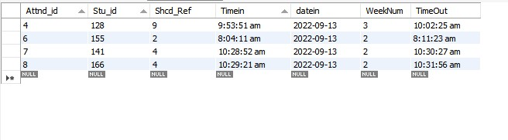

* **System Integration and Acceptance Testing**

System testing will usually be the phase where the decision to release the software will be heavily influenced. Functional and non-functional attributes of the system such as reliability, maintainability and security and requirement specifications of the system are assessed. This is a black box testing technique where the tester must only know the expected behavior without having to know the internal of the systems implementation.

* **Functional System Requirement Testing**

The system at this stage were verified whether it could meet the customer standard because there is a saying "customers always know what they don’t want”. The team tried to validate each customer requirement against the system provision and the table below depicts the test results.

|  |  |  |
| --- | --- | --- |
| System Results-oriented | User requirement | Remarks |
| Sign up and login provided | Entry to enroll new user to the system | Pass |
| Support for biometric finger print | Able to receive finger print | Pass |
| Able to create new course schedule | Entry provided to create a new course schedule | Pass |
| Able to generate systematic report on each student | Access student information and generate report | Pass |
| Able to take daily attendance of students | Entry to take attendance | Pass |

* **Non-Functional Requirement Testing**

|  |  |  |  |
| --- | --- | --- | --- |
| Test | Steps | Expected Results | Remarks |
| Security | Try to access the database without going through the server to verify | Access denial | Was denied Access |
| Data Integrity | Save data through the database  Request for that data | The data is same as the one saved | Data was not Altered |
| Scalability | Increase the capacity of the database to accommodate more tables | The new tables were added and the old one wouldn’t break | New tables added and other tables still intact |

**4.4 Chapter Summary**

The chapter thoroughly demonstrated various experiment carried of by the team for the acceptance of the prototype system. It was observed that the system is efficient to carry on the duty intended and provides the reliable and verifiable results which could aid in the decision making.

Chapter Five

**Summary, Conclusion and Recommendations**

**5.1 Introduction**

This chapter provides a quick summary what the entire system is about, a conclusion that indicates whether the stipulated objectives have been achieve and finally, the recommendation which describes other functionality to be added to make the system much better.

**5.2 Summary**

In all, the system is guaranteed to yield effective results when used. Having studied the trend of taking attendance in All Nations University College, the system was developed by analyzing the flaws of the current system and implementing the necessary procedures to meet these flaws head on. The design development process was given much attention in terms of database design, the implementation of the data flow diagram and the analyzing of the system using the context analysis diagram. This helped in the setting up the relationships between external and internal factors of the whole process. Testing was done comprehensively to remove all bugs in order that the software works efficiently.

**5.3 Conclusion**

The team with the support from the faculty of Technology education and engrossment of stipulated Information technology education students in decision making helped to achieve the stated objectives. Through an observation, interview and follow-ups, the team were able to come out with a system specification and user functional requirement which speeds up the process. At each step of Rapid Application Development selected for this project, a prototype version was presented to the customer for testing at each stage since customers always know what they don’t want.

**5.4 Recommendation**

**5.5 Chapter Summary**

The chapter provided a brief summary of the system and the necessary future projections for any researcher deem it very prudent to take study on the same filed.

**References:**